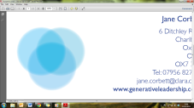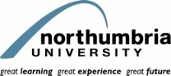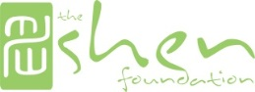<EMPTY><EMPTY>

**Generative Leadership Centre**

**University of Oxford**

***Initiating Dialogue in the South*** *a 1-Day Symposium*

**Be a Leader in Wellbeing and help uncover a path to a healthier, brighter, more productive and more sustainable future.**

Register HERE or Contact us:

**ph** 555.555.5555

**fx** 555.555.5555

[**www.whichsitegoeshere?.com**](http://www.whichsitegoeshere?.com)

**Date: 8th April 2013**

**Time: 10am to 3pm**

**Venue: TBC**

A holistic state of wellbeing can not only improve the state of an individual but all those around them and all the activities with which they are involved. This means improving productivity, ethical and sustainable innovations and happier and healthier working environments meaning fewer sick days and less staff turnover.  
**How we’re achieving this?**    
On 6th March 2012, Team - Spinlondon initiated a dialogue on 'Leadership in Well-being' in the Northeast in collaboration with Northumbria University. Thanks to Prof. Safwat Mansi, Petia Sice, Dr. Bisong Guo and all others who participated and contributed to the workshop. This has now led to several follow-on discussions and dialogues, building momentum in the North, specifically with several workshops in Forres, Scotland in collaboration with Shen Foundation.

INNOVATIVE WELLBEING IDEAS  
Acting as a catalyst for several conversations and projects in various locations and with various groups, now the Spinlondon Network Limited, Shen Foundation and Northumbria University are pleased to bring together a very select group of leaders to share their innovative wellbeing concepts and practices. This will be a unique opportunity to discuss options to battle the growing problems with lack of wellbeing in today’s workforce and society.  
  
BE A LEADER IN WELLBEING…  
and join us for this movement for wellbeing on a personal, organisational, social and national level. We aim to catalyse various dialogues and interesting and exciting projects in the South by pooling our resources and expertise together.

**Wellbeing on a Personal, Corporate, Social and National Level**

**LEADERSHIP IN WELLBEING**